Operational Concept Description (OCD)

Student Scheduling System Part II

Team #10

Bo Wang: Project Manager
Bohan Zheng: Prototyper
Shuai Wang: System Architect
Chenyang Bai: Feasibility Analyst
Rui Tong: Requirements Engineer
Xiaoran Li: Life Cycle Planner
Frank Varela: IIV&V

04/04/2014

Version History
Date | Author | Version | Changes made | Rationale
09/24/2013 | Bohan Zheng  Shuai Wang | 1.0 | - Create Purpose of the OCD, Status of the OCD, Program Model, Benefits Chain Diagram, System Boundary and Environment Diagram, and information on current system | - Create the initial document to fit the course and project content
10/13/2013 | Shuai Wang | 2.0 | - Fix bugs and update information in Program Model, Benefits Chain Diagram, System Boundary and Environment Diagram, and information on current system  - Create information on current system, System Objectives, Constraints and Priorities, Proposed New Operational Concept, Organizational and Operational Implications | - Improved document consistency  - Suggested changes for sections 2.1, 2.2
10/30/2013 | Shuai Wang | 2.1 | - Refine the defects decription  - Refine the Benefit Chain  - Refine the workflow | - Modify the description  - Improved document consistency
11/24/2013 | Shuai Wang | 3.0 | - Modify the Level of Service part | - Providing algorithm impovement evidence

Table of Contents
Operational Concept Description (OCD) i
Version History ii
Table of Contents iii
Table of Tables iv
Table of Figures v
1. Introduction 1
2. Shared Vision 2
2.1 Overview of the system 2
2.2 System Boundary and Environment 4
3. System Transformation 5
3.1 Information on Current System 5
3.2 System Objectives, Constraints and Priorities 7
3.3 Proposed New Operational Concept 10
3.4 Organizational and Operational Implications 12

Table of Tables
Table 1: The Program Model 2
Table 2: Artifacts 5
Table 3: Capability Goals 7
Table 4: Level of Service Goals 7
Table 5: Relation to Current System 8

Table of Figures
Figure 1: Benefits Chain Diagram of Student Scheduling System 3
Figure 1: System Boundary and Environment Diagram 4
Figure 1: business workflow 6
Figure 1: Element Relationship Diagram of Student Scheduling System Part II 10
Figure 2: Business Workflows Diagram of Student Scheduling System Part II 11

Introduction
This document provides, in detail, the shared visions and goals of the stakeholders of the Student Scheduling System Part II for the Computer Science Department of Steven Institute of Technology. The main success-critical stakeholder of the project is Professor David Klappholz who is the project owner and adviser at Stevens, and other success-critical stakeholders include:
• Undergraduate students of Stevens (undergraduate CS, IS, and CyS majors)
• Course directors
• Administrators
• Software maintainers
The status of the OCD is second version in the Exploration phase. It will identify the success-critical stakeholders and offer the shared version of stakeholders, which include program model, benefits chain and system boundary, environment diagram, system Purpose, and desired capabilities and goals.

Shared Vision

Overview of the system
The vision for this system is to create an easier and less complicated way for students to be able to create schedules in order for them to graduate in the time frame they desire. The major goal for system part II is to improve efficiency for students to generate study plan with more clear and friendly user interface. As shown in Table 1, this is achieved by the system being planned with the cooperation of Steven's Institute staff, faculty and students.

Table 1: The Program Model
Assumptions:
- All undergraduate students and advisors will use the system.
- The system will keep updating the courses information and graduation requirement.
Stakeholders | Initiatives | Value Propositions | Beneficiaries
- Former Developer  - Developer  - Administrator  - Courses director  - Undergraduate student  - Maintainer | - Review and test the current system  - Develop a new system based on the current system and deliver it  - Fill the database with sufficient data  - Keep updating courses information and graduation requirement.  - Inform students with new system and teach them how to use system  - Study how to use the system  - Maintain and enhance the system | - Save advisers’ and students’ time  - Construct a study plan for students efficiently  - Reduce incorrect courses selection  - Reduce students frustration | - Undergraduate student  - Course director
Cost |  | Benefits
- Development Cost,  - Maintenance Cost, Maintainer,  - Web Server, Web Hosting. |  | - Time of constructing studying plan,  - Efficiency for adviser to inform students with change of courses and graduation requirement,  - Course schedule correctness.

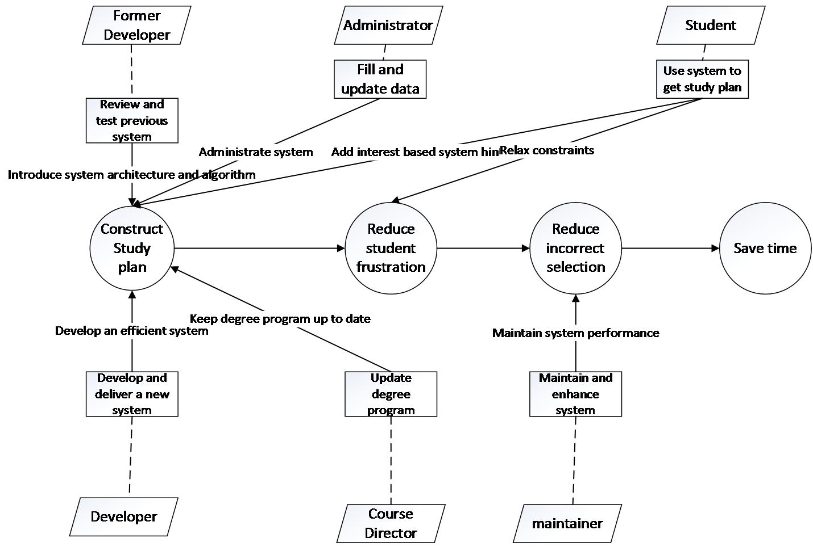
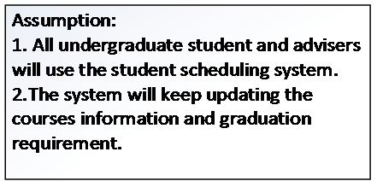
Figure 1: Benefits Chain Diagram of Student Scheduling System

System Boundary and Environment
Student scheduling system part II is a web information system for students and course directors to generate study plan automatically. Though current system can generate study plan, it cannot make sure that students can get study plan in reasonable time. Usually, students cannot get study plan because some non-relaxing interests. The current cannot afford any hints for students to relax their constraints. In system part II, our goal first goal is to offer a more clear way for course director/ administrator to add/ update specific degree requirements, prerequisites, corerequisites constraints and degree requirements. The second goal is to design an efficient algorithm to help students enter their desires and help them to generate study plan automatically. The whole process shall be efficient than the previous system, and also make sure to get a correct study plan. The administrator and maintainers should be familiar with support infrastructure such as Java, Play Framework and MySql.

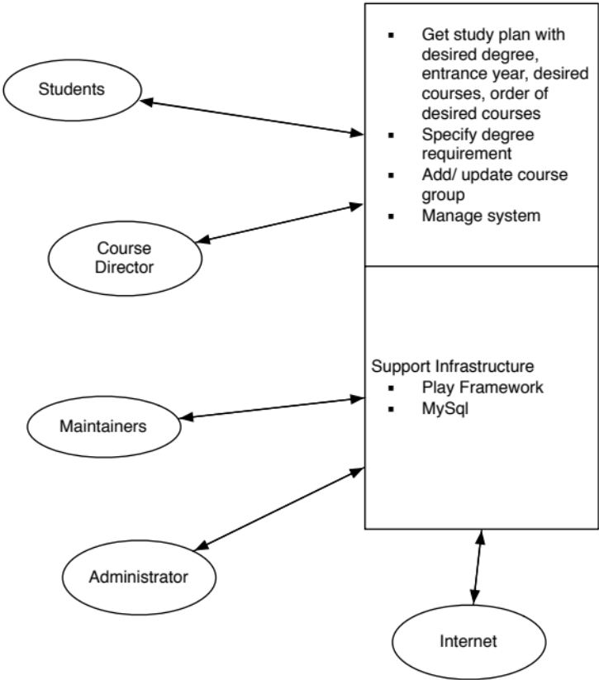

Figure 2: System Boundary and Environment Diagram

System Transformation

Information on Current System

Infrastructure
  - Current system is only a prototype which has not been deployed.
  - The course plans and degree requirements are finished by advisor.
  - The students tell advisors what courses they are taking, how many semesters they want to graduate, and what courses and degree requirements they have already satisfied. That part of the process consumes a lot of time.

Artifacts
Table 2: Artifacts
# | Artifact | Description
1 | List of the courses in database | Plan unstructured list of available courses and general information about them (semesters when it is offered, instructors, etc.) is provided on the website.
2 | Course group | Each course group combined with several courses, e.g. CS 100 level.
2 | Description of the degree requirements. | Description for degree requirement including total graduate credit, and credits for each semester, course group, and prerequisite and corerequisite.
3 | Constraints solver | Calculate both degree requirements and students desires to generate study plan.

Current Business Workflow
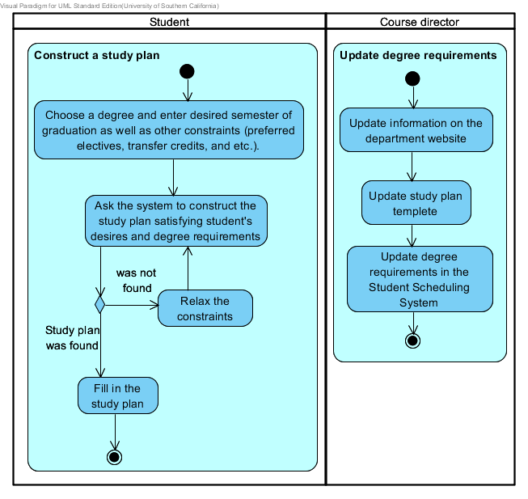
Figure 3: business workflow

System Objectives, Constraints and Priorities

Capability Goals
Table 3: Capability Goals
Capability Goals | Priority Level
OC-1 Degree requirement management: The administrators and course directors should be granted to add/update all course, course groups, requirements and degree programs into database. | Must have
OC-2 User management: The administrators directors should be granted to to add/update course directors account and user information. | Must have
OC-3 Students basic information input: The system shall allow students to input desired degree, entrance year and desired graduate year. | Must have
OC-4 Students constraints input: The system shall allow students to enter their desired courses, transfer credits, failed credits, and desired study order of courses. | Must have
OC-5 Study Plan Output: The study plan should be shown on webpage. | Must have
OC-6 Hint provided for administrators: System should allow administrators to see some hints when he/she inputs degree requirements | Must have
OC-7 Error description: The system should allow students to see the constraints need to be relaxed. | Must have
OC-8 Compatible with previous system: The current system shall be compatible with the previous version of the system written using the Play Framework and MySql. | Must have
OC-9 Efficiency and Correctness: The system shall make sure that the study plan can be generated with correctness more efficiently than previous system. | Must have

Level of Service Goals
Table 4: Level of Service Goals
Level of Service Goals | Priority Level | Referred WinWin Agreements
LOS-1 The algorithm for generating the course schedule shoulde be reduced calculating load. The Searching strategy in directed acyclic graph can be faster than the previous algorithm | Must have | Algorithm Description

Organizational Goals
OG-1: Improve better user satisfaction via clearer and friendlier user interface design.
OG-2: Reduce frustration of the course director via better error hint during degree program construction phase.
OG-3: Reduce frustration of the course director and students during study plan construction phase.
OG-4: Save time by allowing students to create schedules on their own time.
OG-5: Reduces incorrect course selection.
OG-6: Improve speed and reduce the study plan construction time via more efficient algorithm.

Constraints
CO-1: Zero Monetary Budgets.
CO-2: The system must use technological infrastructure that can be maintained by client.
CO-3: The current system shall be compatible with the previous version of the system written by the Play Framework and MySql.

Relation to Current System
Table 5: Relation to Current System
Capabilities | Current System | New System
Roles and Responsibilities | Help students to generate study plan; Help administrator and course director to fill degree requirement into database and update data. | Help students to generate study plan with more efficiency; Afford students, administrator and advisor more clear and friendly user interface; Help administrator and course director to fill degree requirement into database and update data with detail error hints to reduce their frustration; Help students to construct their study plan with detail error hints to reduce their mistakes.
User Interactions | Basic user interaction: students enter desired courses, and some basic history information for example: transfer courses/ failed courses, then get their study plan; Administrator fill in the degree requirements and course selection limitation into database, and advisors update the degree requirements and course selection limitation. | More efficient user interaction: students will be guided by hints when they choose desired courses (transfer courses/ failed courses); Administrator/ course director will be given hints when they add/update the degree requirements and course selection limitation into database  Student could receive the hints to relax their course preference for generating a correct study plan.
Infrastructure | Developed by Play Framework and MySql.  Deployed on USC server. | Developed by Play Framework and MySql.  Should be deployed on SIT server.
Stakeholder Essentials and Amenities | Fulfill the basic requirements (generate study plan). | Develop a more efficient system to generate study plan with higher correctness.
Future Capabilities | Basis for future system development. | Easy for SIT undergraduates and faculty to use; easy for maintainers to manage it.

Proposed New Operational Concept

Element Relationship Diagram
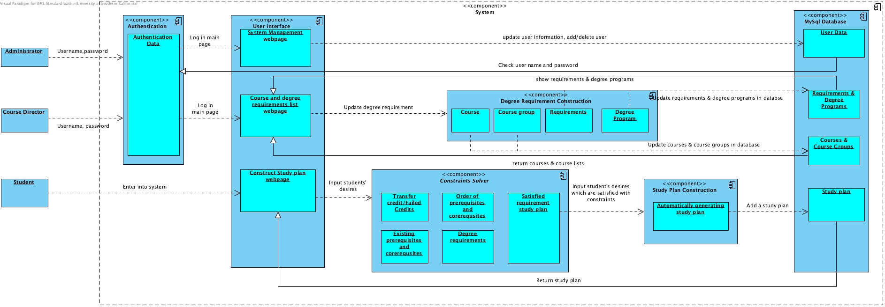
Figure 4: Element Relationship Diagram of Student Scheduling System Part II

Business Workflows
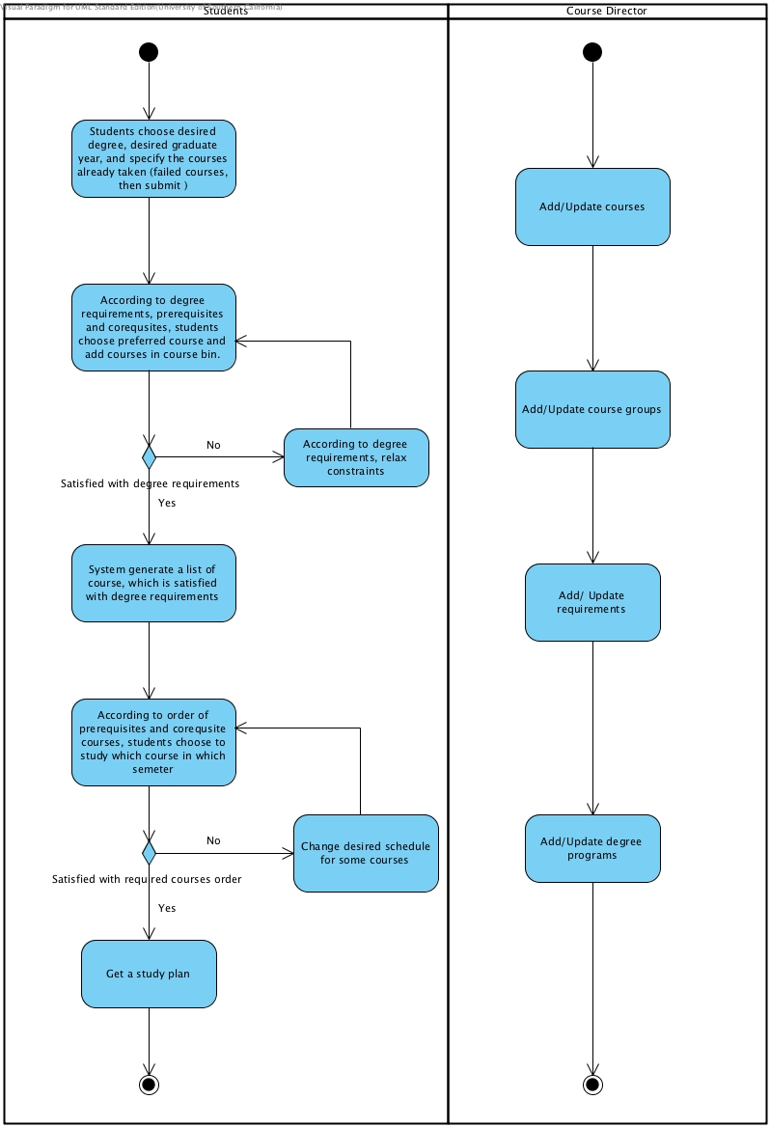
Figure 5: Business Workflows Diagram of Student Scheduling System Part II

Organizational and Operational Implications

Organizational Transformations
- The need to make sure that the if the server in SIT could support for the proposed system
- The need to hire a maintainer to take care of the system.
- The need for system to store study plans.
- The need separately store courses, course groups, requirements and degree programs in database.

Operational Transformations
- The course director needs to add/update degree program as following steps: add courses-> add courses groups-> add requirements ->add degree programs.
- The course directors would have to update the degree programs online. This can be as minor as adding or updating a course in the current degree requirement or as major as adding a new degree programs and its corresponding requirements. They may also authorize any other employee (ex: a student worker, part time employee) to update degree programs.
- The proposed systems reduce workloads for course directors. They don’t need to teach students how to generate study plan manually, update degree requirements and course selection limitation by modifying the department website than announce it to all students. Also they don’t need to help students to fix their plan bugs manually, With the proposed system, they could make any requirement change by updating database and teach students how to use the systems.
- Students don’t need to fill in their desire in one step and wait for result coming out without error hints. With new system, students needs to fill in their desires step by step: add basic & history information-> add desire courses -> add desire course order ->relax desires -> get study plan.

